**Multilevel Inheritance**

**Multilevel inheritance** refers to a mechanism in OO technology where one can inherit from a derived class, thereby making this derived class the base class for the new class. As you can see in below flow diagram C is subclass or child class of B and B is a child class of A

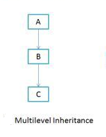**Example**

**class** X

{

**public** **void** methodX()

{

System.***out***.println("Class X method");

}

}

**class** Y **extends** X

{

**public** **void** methodY()

{

System.***out***.println("class Y method");

}

}

**class** Z **extends** Y

{

**public** **void** methodZ()

{

System.***out***.println("class Z method");

}

**public** **static** **void** main(String args[])

{

Z obj = **new** Z();

obj.methodX(); //calling grand parent class method

obj.methodY(); //calling parent class method

obj.methodZ(); //calling local method

}

}

Output

Class X method

class Y method

class Z method